**Unity Project**

**Free hand drawing application**

**User Document**

By

**Minh Dung Do**

1. **Introduction**

This guide consists of several instructions designed to support the user download and use the application.

1. **Software requirement**

The application is currently compatible with Windows and Android. Minimum requirements recommended for applications developed with Unity3D are mentioned below.

|  |  |
| --- | --- |
| **System** | **Minimum requirements** |
| Desktop | * Windows 7 SP1+ * CPU - SSE2 instruction set support * GPU - Graphics card with DX10 (shader model 4.0) capabilities. |
| Android | * OS 4.1 or later * ARMv7 CPU with NEON support or Atom CPU * OpenGL ES 2.0 or later. |

Though the minimum requirements depend on the complexity of the project. But this is for guarantee that the application will able to run and run smoothly

1. **Download the application**

<https://github.com/MinhDungDo/freeHandDrawing>

Above is the link for download the whole package including:

* System Documentation
* User Documentation
* Executable application in zip file
* The entire project in zip file

After download the user can unpack the “Executable application in zip file” and run the .exe file to open the application.

1. **Function introduction**

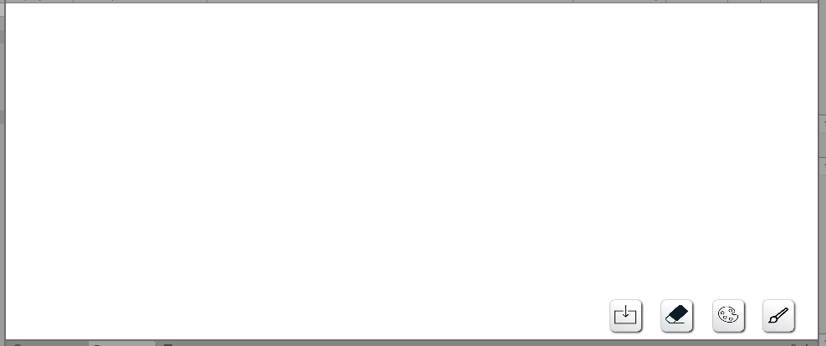

There are 4 buttons in the application:

* Brush type/size (future update)
* Color picker
* Total erase
* Save scene

**4.1 Color picker**

The user can select the brush color by clicking the Color picker button(picture below). After the color palette appears, the user can edit the slider to choose their desired color.

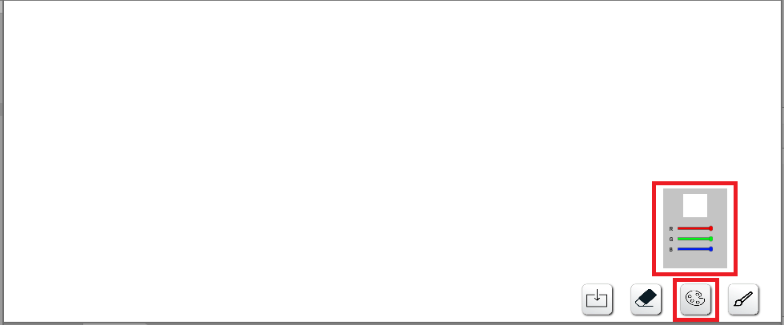

They can close the color palette by clicking on the button again.

**4.2 Total Erase**

The user can erase all the lines by clicking on the Total erase button(picture below).

Warning: this button will erase **all the lines** in the scene

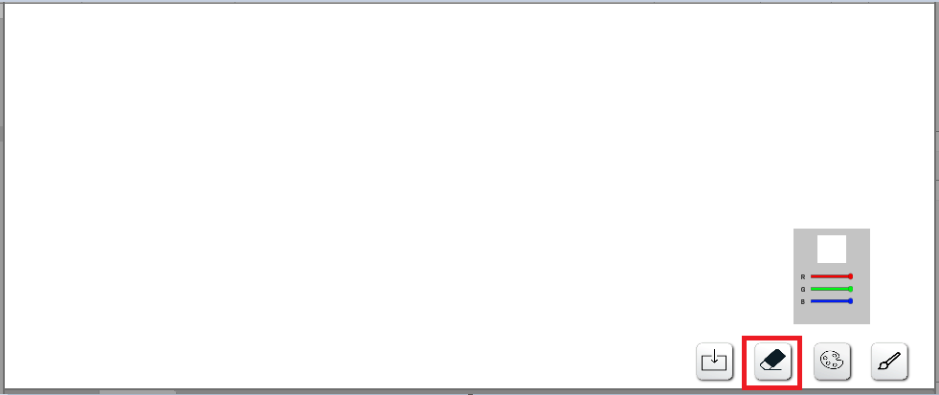

**4.3 Save scene**

After finishing the drawing, the user can save their product by clicking the save button(picture below).

